Chemical risk assessment
Describe the work process or the experiment to be performed.
Are there any critically dangerous steps in the work procedure?
☐There exists an written protocol, reference:

Create a list containing all used chemicals that requires labeling according to REACH, also cross off the assigned pictograms.
The MSDS can be found on www.kemibrug.dk
CAS-number | Product name | Concentration | Amount | 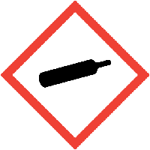 | 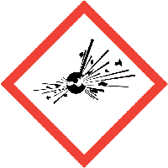 | 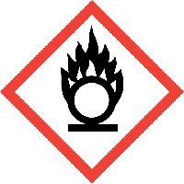 | 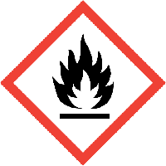 | 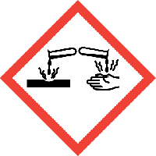 | 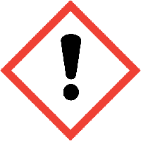 | 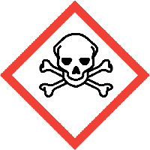 | 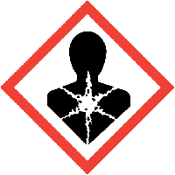 | 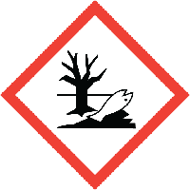
Assess the possible ways of exposure and the threshold limit values. Caution, threshold limit values may differ for pregnant and breastfeeding.
Use www.kemibrug.dk and CLP sandbox tool if necessary.
☐Risk off consumption
☐Risk off breathing
☐Risk off skin contact
☐Risk off eye contact
☐Risk off creating hazardous agents in the process
☐Other
Incase off unexpected exposure describe the correct action plan, use www.kemibrug.dk and the CLP sandbox tool if necessary, pay attention to precaution P300-399.
Duration of the work process or the experiment:
Frequency of the work process or experiment:

Chemical waste/ Hazardous waste. Describe the correct disposal, consider the waste group for both the chemical and mixed products. Remember to consider which container is certified to the requirements. Help can be found on www.kemibrug.dk
O – Strongly oxidizing and reactive with water.
K – Contains mercury
Z – Empty packaging and clinical waste
T – Pesticides
X – Inorganics: Acid, base, salts and metals
A – Mineral oil without emulsifiers
B – Halogens
C – Organic flammable waste
H – Organic waste with a high water content

Substitution. If any of the chemicals is assigned the following pictogram substitution must be considered.
Is substitution possible: Yes☐ No☐
Reason:

Describe the necessary personal protective equipment to minimize the risk related to the work:
Protective equipment:
☐ Point suction
☐ Fume hood
☐ LAF bench
☐ Encapsulation of the process
☐ Other (Describe)
Personal equipment:
☐ Dress code – Lab coat
☐ Gloves
☐ Safety googles
☐ Respiratory protection (Describe the filter requirements)
☐ Other (Describe)
If relevant: | Medicinal threshold limit values, threshold values determined by Arbejdstilsynet, and conditions still not described.

Necessary actions to improve the safety, suggestions most be added to the APV action plan.
 |  | Can the risk be justified? Actions necessary? | Yes☐ No☐  Yes☐ No☐
Instruction level  ☐Oral  ☐Oral and written  ☐Education required | Date and initials for completed instruction:

Approval and document information:
Center: | Location: | Created by: | Approved by: | Date:

